DTLab Challenge Rack

Last updated 11.7.2021

# Idea

The [Digital Transformation Lab](https://hm.edu/sites/dt_lab/) (DTLab) currently works with a PDF based [intake form](https://w3-mediapool.hm.edu/mediapool/media/baukasten/img_2/dtlab_1/dtl_dokumente_1/2020-11_DTLab_Challenge_Intake_Form.pdf) to capture the most relevant information from a challenge sponsor and with different Excel files (challenge pipeline, challenge overview per semester) to manage the lifecycle. This approach is laborious, error-prone and intransparent. Therefore, the idea is to capture challenge proposals via an online form and store all relevant data in a central database. This allows an easier management of challenges and closer collaboration with all personas involved (challenge sponsor, coordinator, and professor).

As [Cloud Innovation Centers](https://aws.amazon.com/government-education/cloud-innovation-centers/) (CICs) globally are facing a similar challenge, the goal is to develop a solution that can be reused or at least adapted

# Challenge Lifecycle

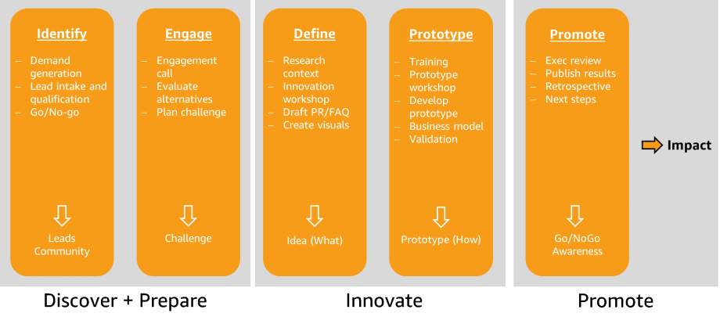

# Persona

**Challenge sponsor** – the representative of a public sector organization submitting a challenge to the DTLab.

**DTLab coordinator** – an assigned coordinator at the DTLab who manages a challenge along its lifecycle (qualification, matching etc.)

**Challenge taker** – a person representing a team that takes on a challenge, e.g. a teacher or a startup lead.

# Backlog

See Challenge Metadata for details on the data actually used to describe a challenge along its lifecycle.

|  |  |  |  |
| --- | --- | --- | --- |
| **No** | **Prio** | **User Story** | **Comment** |
| 1 | High | As a challenge sponsor I want to submit a challenge proposal to the DTLab. |  |
| 1a | Low | As a challenge sponsor I want to update a challenge proposal to the DTLab. |  |
| 2 | High | As a DTLab coordinator I want to get an overview of all current challenge proposals. | Use filters for phase, organization, tag, date range etc. |
| 3 | High | As a DTLab coordinator I want to review a proposal, give it a title and flag it with tags |  |
| 4 | High | As a DTLab coordinator I want to qualify a challenge proposal. |  |
| 5 | High | As a DTLab coordinator I want to score a challenge proposal |  |
| 6 | High | As a DTLab coordinator I want to set the type of a challenge | We have predefined types of challenges. This decision is key for the next steps. |
| 7 | High | As a DTLab coordinator I want to match a challenge proposal to a challenge taker. |  |
| 7a | High | As a DTLab coordinator I want to assign a challenge proposal to a challenge taker. | Challenge status is marked as ‘assigned’, potential co-takers can still express interest to contribute |
| 8 | High | As a DTLab coordinator I want to get an overview of all challenges/of a cohort | Replaces challenge overview |
| 9 | Medium | As a DTLab coordinator I want to plan the key milestones for a challenge. | Predefined set of milestone types, e.g. |
| 10 | Medium | As a CIC coordinator I want to update the phase and the milestones of a challenge |  |
| 11 | Medium | As a challenge taker I want to get an overview of all current challenge proposals. | Similar to 2, just for a different role and with fewer details. |
| 12 | Medium | As a challenge taker I want to express my interest to take on a challenge or project. | Metadata missing  May be a ‘like’/’favorites’ |

# Requirements

* Challenge intake needs to be integrated into DTLab website (embedded or link)
* Support for multiple languages (at least German and English)
* User management
* Results will be published under an Open Source license
* Prepare for reuse by other CICs

# Dialogs

|  |  |
| --- | --- |
| Challenge Sponsor | Challenge intake – **Step-by-step Survey** |
|  |  |
| DTLab/CIC Coordinator | Challenges overview (by cohort, overall), scoring, deleting unwanted information |
|  | Challenge details |
|  |  |
| Challenge Taker | Challenge overview (with limited information) – Challenge gallery, easy to browse |
|  | Challenge expression of interest ‘add to favorites’ with Name, Email address, Level of interest, potential student group, and more (?) |
|  | Challenge plan – Favorites list |

# Flow of a challenge

Proposal Overview

Qualify Proposal

Notify CIC Coordinator

Score Proposal

Set Challenge Type

Submit Proposal

Match Challenge

Challenge Rack

Notify Challenge Takers

Plan Challenge

Challenge Overview

DTLab Community

Publish Challenge

Challenge Plan

Publication Overview

Update Challenge

Express interest

**Qualify**

**Plan**

**Execute**

# Challenge Metadata

The following list contains the necessary metadata to manage a challenge along its lifecycle. Please note: The sections reflect a logical, but not necessarily a chronological order.

|  |  |  |  |
| --- | --- | --- | --- |
| **Section** | **Title** | **Type** | **Description** |
| General | ID | Text | Unique identifier for challenge. Should be self-speaking, we need to define a syntax |
| Lifecycle | Phase | Text | Phase of the challenge, e.g. Identify or Engage, see Challenge Lifecycle |
|  | Status | Text | Status of the challenge, e.g. qualified, matched, planned, assigned, started and published |
| Visibility | Visibility status | Int | Is this proposal visible in the challenge gallery? What parts are visible |
| Sponsor POC | POC Name | Text | Name of the central POC. |
|  | POC Title | Text |  |
|  | PoC Email | Text |  |
|  | POC Phone | Text |  |
|  | Opt-In | Boolean | Opt-in for further communication, e.g. DTLab newsletter |
| Sponsor Organization | Organization Title | Text | An Organization might have multiple POCs and challenges |
|  | Organization City | Text |  |
|  | Organization Mission | Text |  |
|  | Organization Website | Text |  |
|  | Submission Date | Date | The date the challenge proposal was submitted |
| Challenge | Title | Text | To be filled out by CIC coordinator |
|  | Challenge Statement | Text | In the format “Howe might we … for … so that …” |
|  | Challenge Description | Text |  |
|  | Key Stakeholders | Text | Who are the key stakeholders? Do the support the challenge? |
|  | Problem History | Text | What has the challenge sponsor already done to solve the challenge? |
|  | Challenge Support | Text | How does the challenge sponsor plan to support the challenge (people, knowledge, data etc.)? |
|  | Leadership Support | Text | Does the challenge have leadership support? |
|  | Criteria of Success | Text | When would a challenge be successful for the sponsor? |
|  | Next Steps | Text | How does the challenge sponsor intend to turn results to life? |
|  | Tags | Text | List of tags, e.g. healthcare, sustainability. To be filled out by CIC coordinator. We should work with a taxonomy |
| Qualification | Real-World Problem | Boolean |  |
|  | Cloud Potential | Boolean |  |
|  | Co-Creation | Boolean |  |
|  | Open-Source Publication | Boolean |  |
| Scoring | Societal Impact | Integer | 0-5 with 0 being the lowest and 5 being the highest score. 0 is a blocker and disqualifies the |
|  | Level of Innovation | Integer |  |
|  | Feasibility | Integer |  |
|  | Scalability | Integer |  |
|  | Executive Support | Integer |  |
|  | Strategic Alignment | Integer |  |
|  | Digital Prototype | Integer |  |
|  | Score | Integer |  |
| Format | CIC Format | Text |  |
| Matching | Faculty | Text | Note that multiple professors might collaborate with their students. In that case we need a primary POC but also want to capture the other students |
|  | Professor | Text |  |
|  | Email | Text |  |
|  | Number of Teams | Integer, optional |  |
|  | Number of Students | Integer, optional |  |
| Plan | Start Date | Date |  |
|  | End Date | Date |  |
|  | Cohort | Text | Eg. Winter Semester 21/22 |
|  | Milestones | List | List of key milestones, e.g. workshops or final presentation |
| Publication | Publication URL | Text |  |
|  | GitHub URL | Text |  |
|  | Publication Date | Date |  |

# Questions

1. How do we inform challenge takers?

Challenge takers without challenge ‘like’ challenge and input Email Address when liking

1. Do we give all professors access to the project rack?

Professors = Challenge takers without challenge can read and like all challenges

1. How do challenge takers inform the CIC about a challenge they want to take on?

Challenge takers without challenge ‘like’ challenge

1. What roles (logins) do we want?

Roles:

DTLab coordinator – login & rights to create, read, update, delete all challenges

Challenge sponsor – no login, just create challenge proposal

Challenge taker without challenge - no login: read and like all challenges (use persistent cookies for favorites list)

Challenge taker with challenge assigned – login assigned by DTLab coordinator; update challenge metadata contributing challenges